3. Adjusting Entries: 4. Move Credits About Accounts Years

Table of Contents
Move Credits About Accounts/Years 3
Individual 4
All Parcels 5

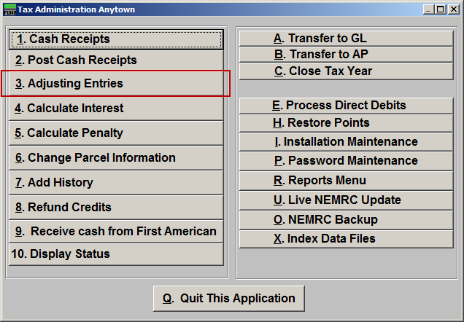
Click on “3. Adjusting Entries” from the Main Menu and the following window will appear:

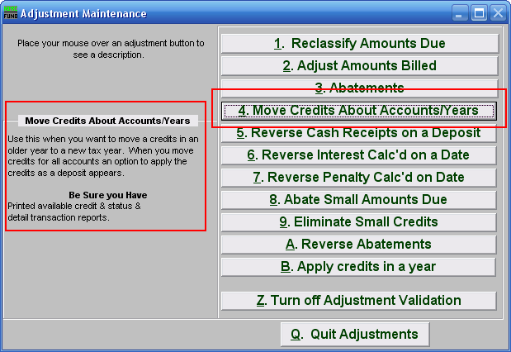
Consider the description that appears when you place the mouse over “4. Move Credits About Accounts/Years.” Click “4. Move Credits About Accounts/Years.” and the following window will appear:

Move Credits About Accounts/Years

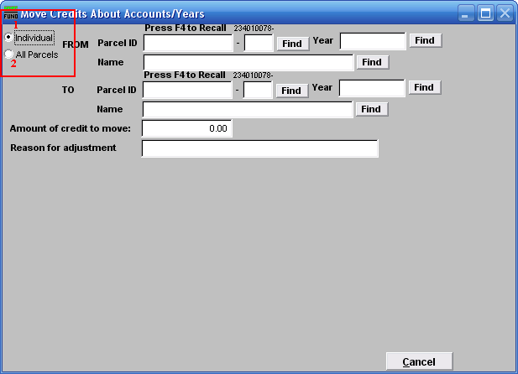
- Individual: Click to choose this option if you want to move Credits from an Individual Parcel to another Parcel.

- All Parcels: Click to choose this option if you want to move Credits for an entire Tax Year to another Tax Year.

Refer to the section below that relates to your choice:

Individual
If you chose “Individual” the following window will appear:

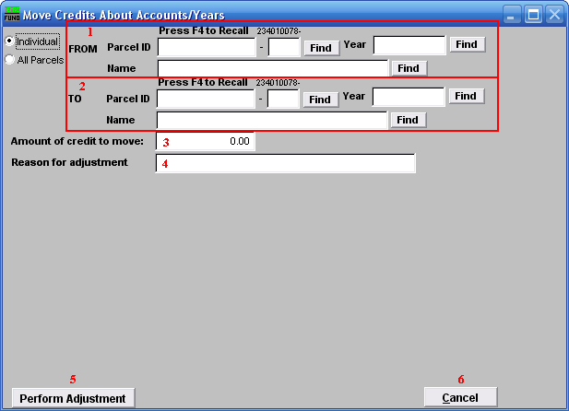
- FROM: Select the Parcel and Year you wish to move Credits from. For additional information on finding Parcels, refer to TA GENERAL PARCEL LOOKUPS.

- TO: Select the Parcel and Year you wish to move Credits to. For additional information on finding Parcels, refer to TA GENERAL PARCEL LOOKUPS.

- Amount of credit to move: Enter the amount of credit to move. This value can be found on the available credit report.

- Reason for adjustment: Define a comment to store with this transaction.

- Perform Adjustment: Click this button to have the software process this task.

- Cancel: Click “Cancel” to cancel and return to the previous screen.

All Parcels
If you chose “All Parcels” the following window will appear:

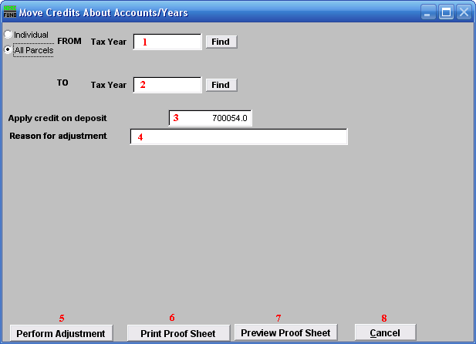
- FROM: Select the Tax Year you wish to move Credits from. For additional help with finding a Tax Year, refer to TA GENERAL TAX YEAR LOOKUPS.

- TO: Select the Tax Year you wish to move Credits to. For additional help with finding a Tax Year, refer to TA GENERAL TAX YEAR LOOKUPS.

- Apply credit on deposit: The deposit number offered is the current number as controlled by the software. This number will group this particular activity for processing.

- Reason for adjustment: Define a comment to store with the transaction.

- Perform Adjustment: Click this button to have the software process this task.

- Print Proof Sheet: Click this button to print a report for these adjustments. Refer to GENERAL PRINTING for more information.

- Preview Proof Sheet: Click this button to preview a report for these adjustments. Refer to GENERAL PREVIEW for more information.

- Cancel: Click “Cancel” to cancel and return to the previous screen.

